Lab - Manage Azure resources by Using Azure CLI Student lab manual

# Exercise 1

## Task 1: Start a Bash session in Azure Cloud Shell

In this task I started a Bash session in Azure Cloud Shell. Because it was the first time starting Cloud Shell I created a storage. (Figure 1)

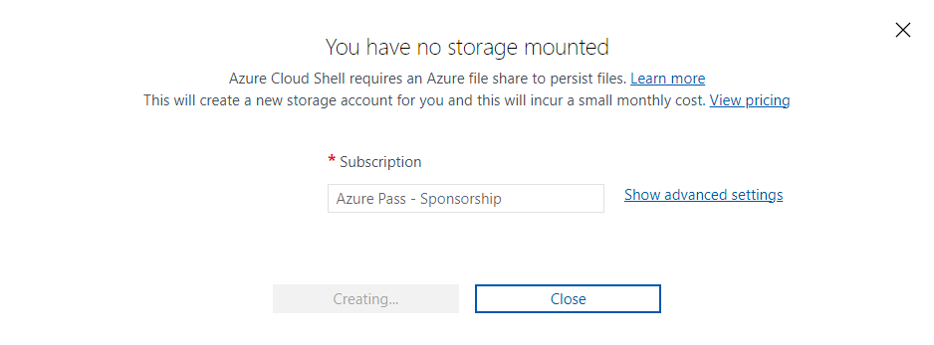

Figure

Here I ensured Bash appears in the drop-down menu in the upper-left corner of the Cloud Shell pane (Figure 2)

Figure

## Task 2: Create a resource group and an Azure managed disk by using Azure CLI

In this task I will create a resource group and an Azure managed disk by using Azure CLI session within Cloud Shell.

Every number corresponds to the subtask in the Lab.

Figure

Figure

Figure

Figure 5.1

Figure 5.2

Figure

Figure 6.1

## Task 3: Configure the managed disk by using Azure CLI

In this task I will be managing the configuration of the Azure managed disk by using Azure CLI session within Cloud Shell.

1. To increase the size of the Azure managed disk to 64 GB. ( Figure 7, Figure 7.1)

Figure

Figure 7.1

1. To verify that the change took effect. (Figure 8)



Figure

1. To change the disk performance SKU to Premium_LRS. (Figure 9, Figure 9.1)

Figure

Figure 9.1

1. To verify that the change took effect. (Figure 10)

Figure